FINAL MASTER ARCHITECTURE [ CRM nErgy Review ] / SOFTWARE 1 — CRM nErgy
Development Concerns

▪ AI GRAPHICS DESIGN ▪ NAVIGATION ▪ FUNCTIONALITY ▪ EFFICIENCY & SECURITY ▪ MAINTENANCE

AI-driven coding, low-code platforms, and cloud-native architectures are reshaping software adaptability in 2026, enabling faster updates and real-time responsiveness to market shifts. Zero-Trust Security and Remote Team Models are also widely adopted to support continuous delivery and scalability.

Before we start building the wireframe , I like to design the CRM nErgy AI logo first. I want to see your team’s logo design capabilities.

It’s important that the wireframe reflects the navigational menu buttons of the software roadmap provided.

When the customers are logged into the platform, I want them to have an experience as if they’re watching a movie on a BIG HI Definition TV screen. When they create a search or apply a prompt, I want the results to be displayed on the big screen. Since our platform is based on the CRM nErgy and AI approach , we want to give it that 3D, Advanced Artificial Intelligence theme. I know when you’re building Data driven platforms, there’s less graphics. I’m looking for a site with the most Advanced AI Graphics to represent our purpose


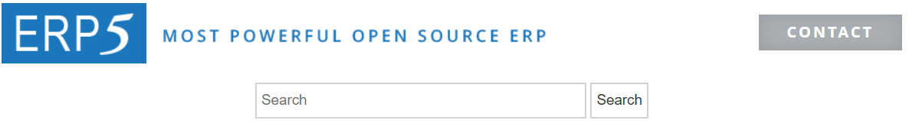
CRM Welcome to CRM nErgy AI Studio

[ A ] CRM nErgy — USER / PORTAL STRUCTURE
- The client has defined four portal concepts:
- The SEA will be the highest-level hidden owner portal.
- Secured Communications eBox, where only the CRM nErgy Super Executive Admin can communicate directly with the Kiaan Tech Team.
In the eBox, SEA and KTT can send chat messages, upload files and have WhatsApp communication capabilities.

[ B ] CRM nErgy ACCOUNT / SUBSCRIPTION FLOW
The client specifically states that CRM Project Management will contain restricted features and that end users can later upgrade to the ERP or both CRM and ERP systems.
On the Mater panel , SEA or KTT can easily update selected features for the core or to be restricted. SEA determines the features.

[ C ] MULTI-TENANT FLOW

[ D ] CRM CORE WORKFLOW
The client's CRM roadmap includes

[ E ] CRM DASHBOARD [ CRM and ERP ]
Customizable, Drag-and-drop

[ F ] TERRITORY MANAGEMENT
Clients could create a Groups or Teams based on the State, City or territory selected.

[ G ] ERP
Customizable, Drag-and-drop

[ H ] PROJECT MANAGEMENT

[ I ] PROCUREMENT

[ J ] SALES & ORDER MANAGEMENT
CRM customer records should connect directly into ERP sales/order operations. [ Lead Management, Marketing ]

Able to create Multiple Commission structures to accommodate different industries. Client can also design their own structures.

Implement a program that can atomically calculate the taxes on sales products based on buyer’s location.

[ K ] FINANCE & ACCOUNTING

[ L ] INVENTORY / SUPPLY CHAIN

[ M ] MANUFACTURING

[ N ] HR + RECRUITING

[ O ] RECRUITMENT WORKFLOW

[ P ] AI RECRUITING

[ Q ] CUSTOMER SUPPORT / [ AI Contact Center ]
when end user needs customer service they can click on AI Contact Center and find a Huge Database of FAQs and get AI Agent help as well. Include a Technical support button , where end users can receive immediate technical support from AI or a Live Agent

R. CENTRAL AI KNOWLEDGE BASE and CUSTOMER SUPPORT should be linked

[ R ] CENTRAL AI KNOWLEDGE BASE
The client's notes specifically describe central FAQ/product knowledge, natural-language questions, and future reuse across the website, CRM assistant, ERP assistant, support, and AI agents.

Q. CENTRAL AI KNOWLEDGE BASE and CUSTOMER SUPPORT should be linked

[ S ] INTERNAL AI SEARCH

[ T ] CRM nErgy AI CONTENT STUDIO [ Each page category requires a special design in this section ]
This section of customers will have a virtual experience feeling of being inside of an AI theme
recording studio, production studio, audio studio, or movie film studio etc.

YouTube Story Telling Videos - 15 minutes
AI Movies 3 – 50 minutes
Tutorial Videos 7 to 10 minutes.
Explainers , 2D , 3D avatars no longer than 7-10 minutes

EDIT VERSION
Bestie – My AI Agent
AAI Muzik Hit Studio
AAI Real Talk
AI Audio Writer
AI ConTalk
AI Film Maker
AI Image TalkR
AI Logo Generator
AI Photo Life
AI Video Crew
AI Visual Workflow
AI VoiceX Change
AAI BIG Movies Lab
Train AI to Speak
AI Video Agent

[ T ] CRM nErgy AI CONTENT STUDIO

E X A M P L E
The Image is the Video Screen for end users to see results.
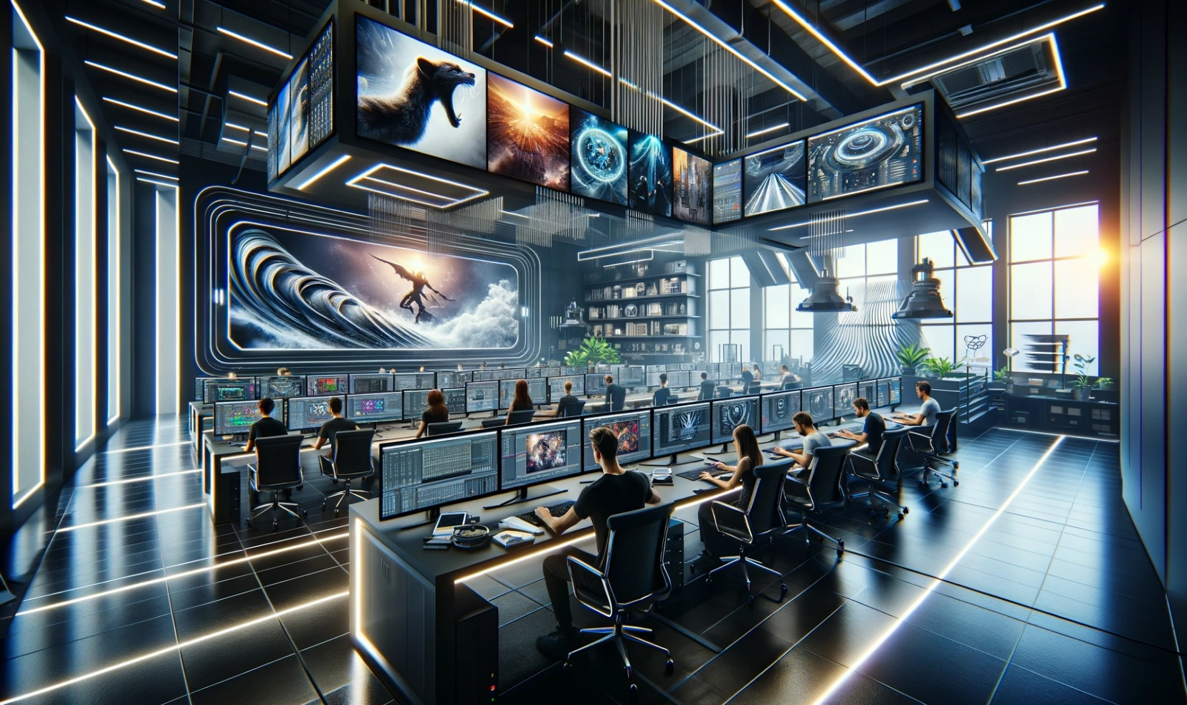
CRM AI Content Studio

Bestie — My AI Agent AAI Muzik Hit Studio AAI Real Talk
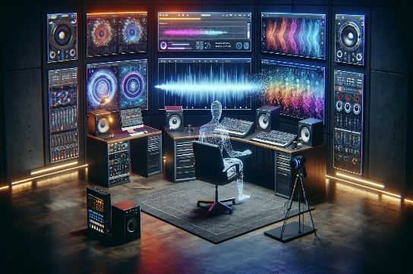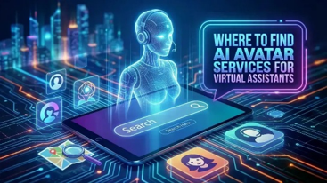

AI Audio Writer AI ConTalk AI Film Maker

AI Image TalkR AI Logo Generator AI Photo Life


AI Video Crew AI Visual Workflow AI VoiceX Change


AAI BIG Movies Lab Train AI to Speak AI Video Agent
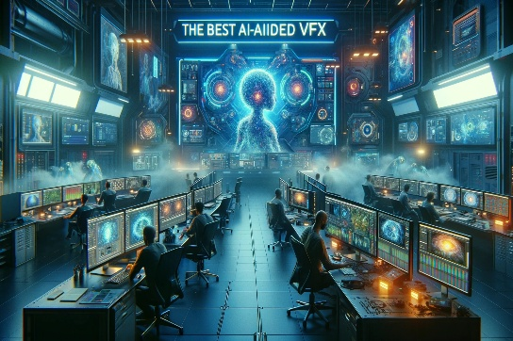

[ U ] CONTENT STUDIO COMMON CREATION FLOW

[ V ] SUPPORTED CONTENT FLOWS

[ W ] BESTIE — MAIN AI AGENT

[ X ] AI VIDEO AGENT — BESTIE

[ Y ] VIDEO AGENT CREATIONS

[ Z ] VIDEO AGENT UX || SAY IT , SEE IT , SHAPE IT , SHIP IT [ EDIT ]
Think It, Speak It, Affirm It, Give it Life

The Image is the Video Screen for end users to see results.
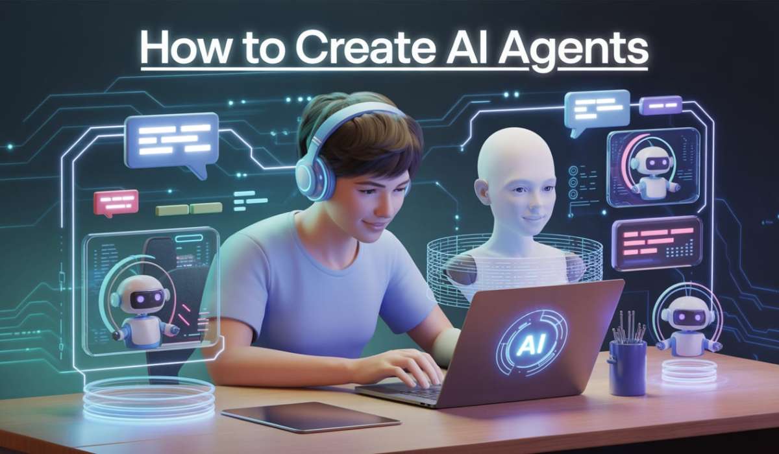
CRM AI Video Agent Studio Creates

Logos 2D Images 3D Avatars
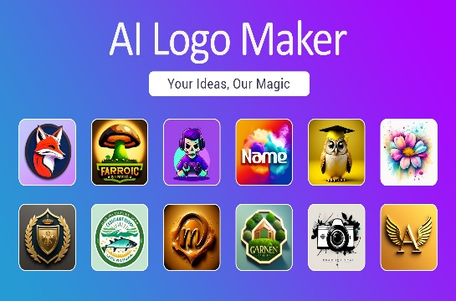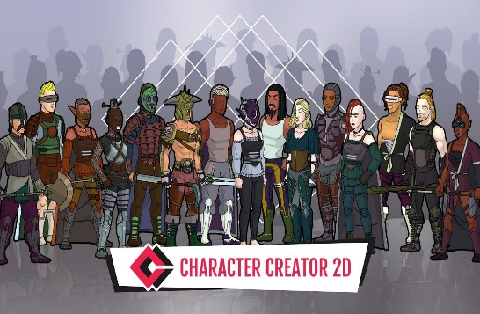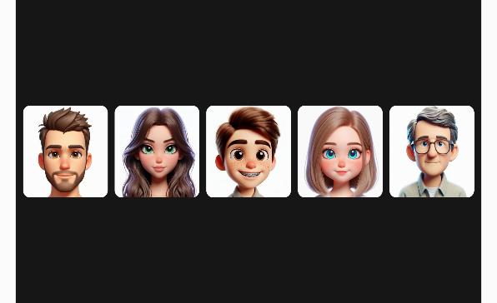

AI Characters Onboarding Videos Tutorial Videos
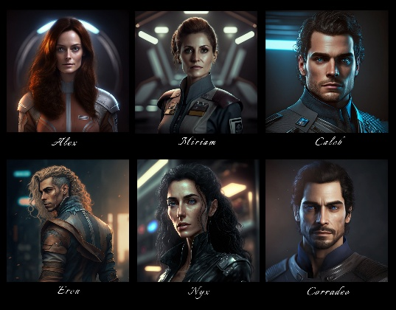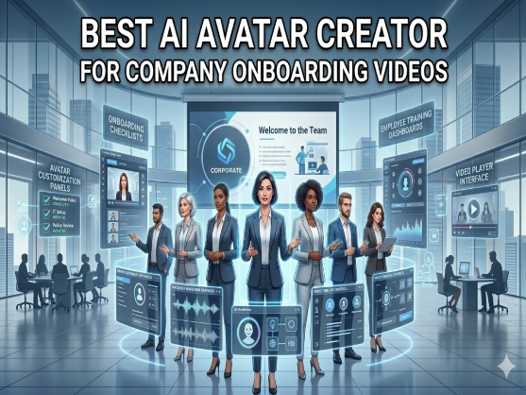
How It Works Videos Explainer Videos Infographic Creations
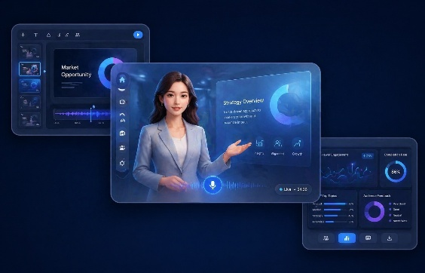

Training Videos Product Ad Videos AI Product Explainer Videos


Social Media Videos Short Story Videos AI Content Studio
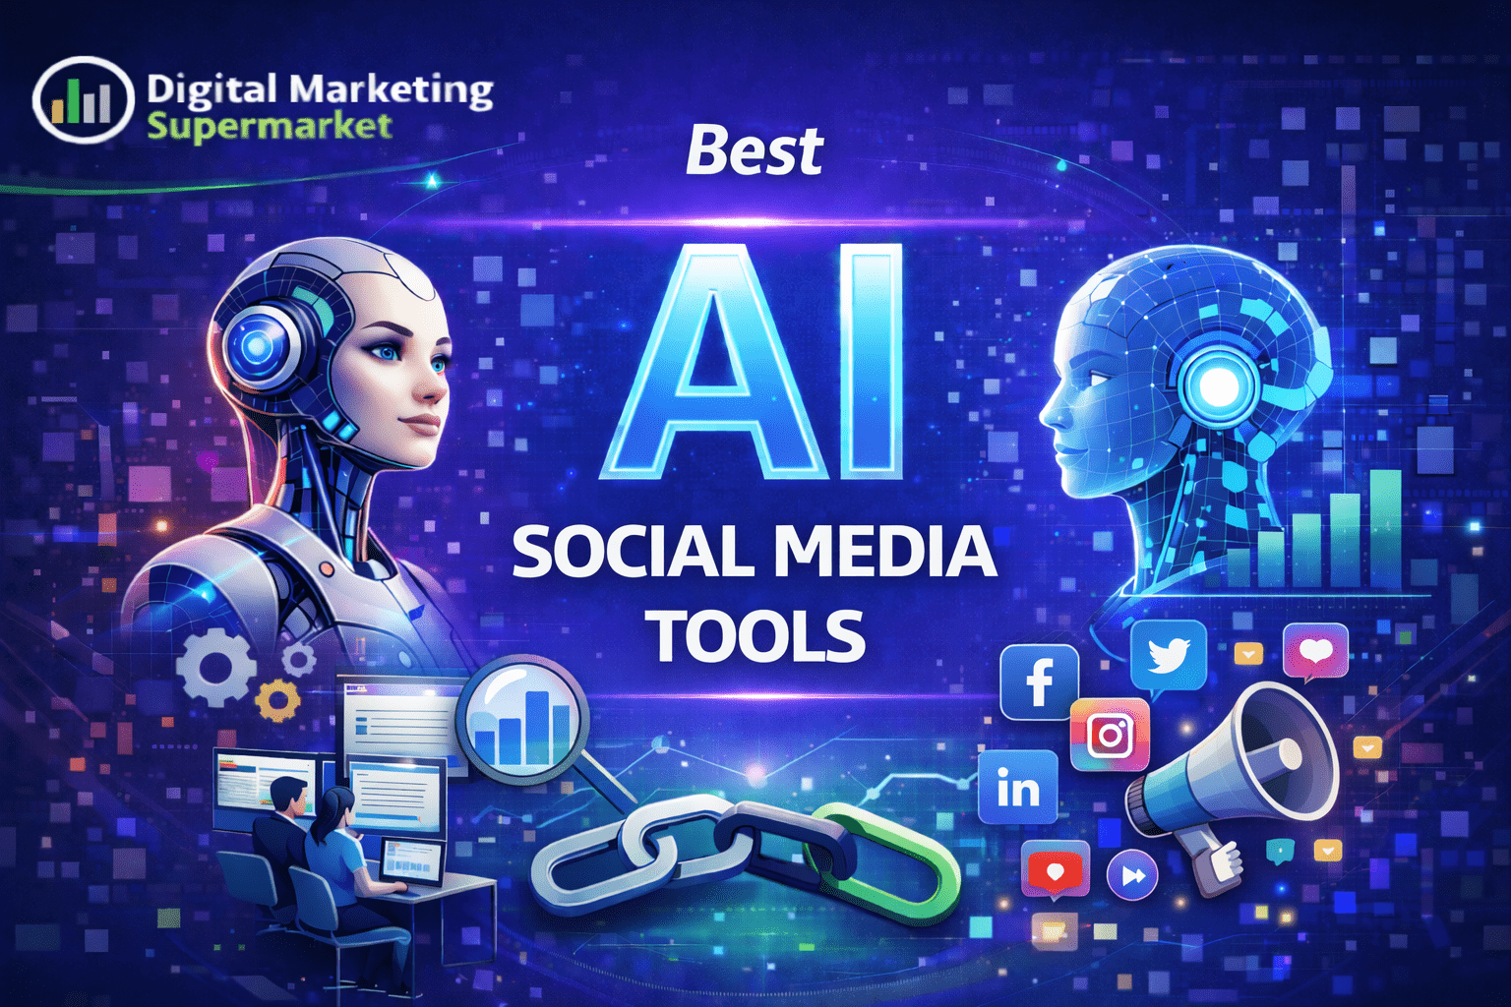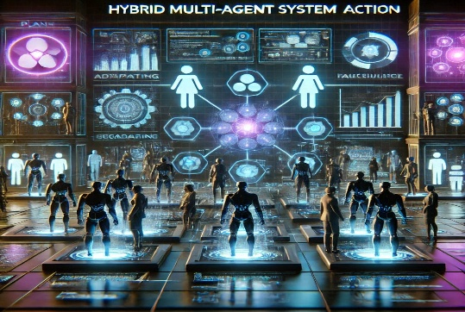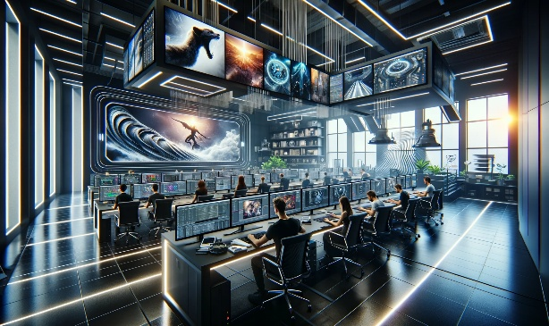

AA. AI VIDEO FORMATS

AB. AI VIDEO / CHARACTER CREATION

AC. AAI BIG MOVIES LAB

AD. AI VISUAL WORKFLOW

AE. VOICE / AUDIO

AF. REDESIGN ANY WEBSITE

AG. AI SECURITY / DATA PROTECTION

AH. CRM nErgy MOBILE APP

The Drag and Drop [ This is an example; clients can set up their favorite APPs on the Favorite Main home page ]

[ The purpose of the CRM nErgy APP is to help manage other APPs used by clients daily.
Having a central folder that helps clients organize and locate other APPs will keep the CRM nErgy APP relevant. This will keep clients using the APP ]

Clients have access to BIG Screen window that displays search results.
Clients can shrink the BIG Screen or stretch the it with their fingers or mouse.
Clients can switch from APP to APP in real time. Once they click on an APP, their BIG screen will display the APP selected.
Clients can minimize that standard Big Screen and make it smaller or expand it to a Full Screen according to their phone screen display.

For example, clients click on Google Maps and search for an address, and the result is displayed on the big screen. Clients have an option of using the standard BIG screen ,or they can expand the window back to the phone carrier standard to a full screen size according to their phone carrier display settings.

AI. MOBILE APP CATEGORIES
My Fav APPs – My CRM nErgy APP
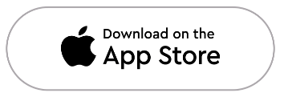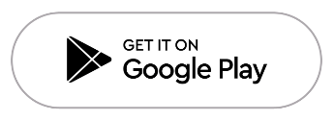
iPhone or iPad Android device [ Create An APP ]


[ Communication | Entertainment | Finance | Digital Payments | Productivity | Shopping | Business Tasks | Health and Fitness | Navigation | Education ]

[ My Fav APPs Home ] ⫷ ( This section displays the APP mode you’re in )

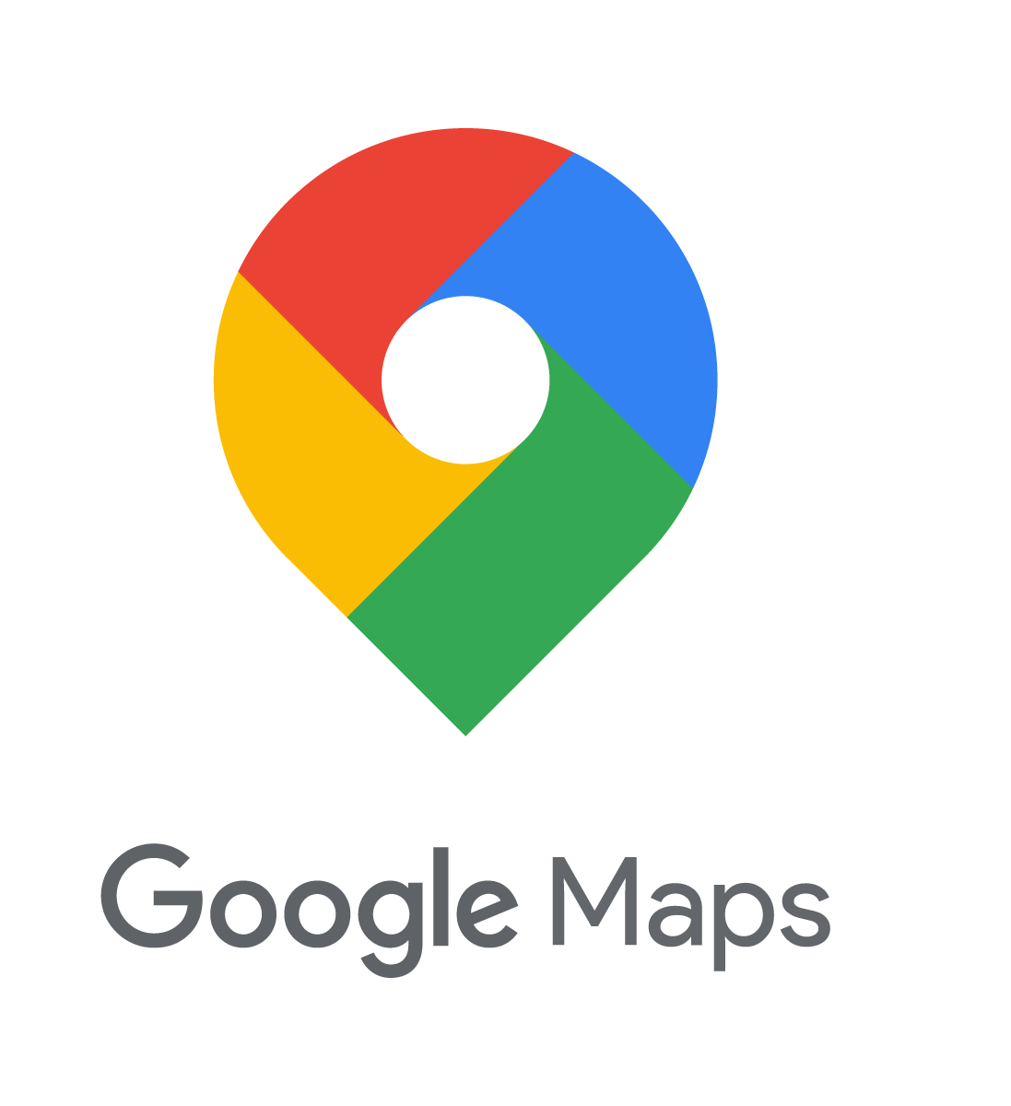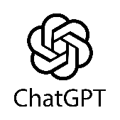

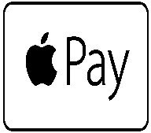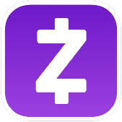

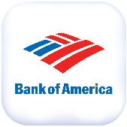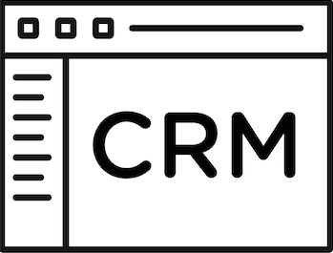

AJ. MOBILE “SECURED STORAGE” — OPEN DECISION
meaning the section of the CRM nErgy APP requires one of the highest form of security to ensure data breach.

SOFTWARE 2 — OAL NETWORK

OAL NETWORK LENDING SOFTWARE

OPM ASAP Loans Marketplace.

AK. BORROWER ENTRY
[ Please review notes on OAL Network website ]

[ AL ] BORROWER ACCOUNT WORKFLOW

[ AM ] BORROWER COMPLETE APPLICATION FLOW

[ AN ] IMPORTANT APPROVAL DIFFERENCE

[ AO ] BORROWER DASHBOARD

[ AP ] BORROWER COMMUNICATION — HARD RULE

[ AQ ] KYC / VERIFICATION

[ AR ] DOCUMENT MANAGEMENT

[ AS ] AI BORROWER SCORE / iNV IQ / Borrower Ranking

[ AT ] TWO SCORING ENGINES

[ AU ] OAL REP / AGENT

[ AV ] REP ASSIGNMENT

[ AW ] OAL REP DASHBOARD

[ AX ] REP COMMUNICATION MODEL

[ AY ] LENDER REGISTRATION

[ AZ ] LENDER DASHBOARD

[ BB ] AI LEAD ALERT

[ BC ] SAVED LEADS — RECOMMENDED DEFINITION

[ BD ] LOAN REQUESTS — RECOMMENDED DEFINITION

[ BE ] LENDER PRIVACY

[ BF ] OAL LIVE MARKETPLACE

[ BG ] OFFER MANAGEMENT

[ BH ] WAITING ROOM / OFFERS
The client explicitly said: “I will handle this section.”
Therefore:
WAITING ROOM / OFFERS
=
CLIENT SPECIFICATION PENDING
We should not invent its final internal workflow.

[ BI ] OFFER ACCEPTANCE TO FUNDING

[ BJ ] ADMIN PANEL

[ BK ] USER CREATION / APPROVAL HIERARCHY

[ BL ] OAL STATUS FLOW

[ BM ] OAL AI HELP DESK

[ BN ] OAL HELP DESK FLOW

NOW THE MOST IMPORTANT PART

SOFTWARE 1 ↔ SOFTWARE 2 LINKUP

[ BO ] WHAT CAN BE SHARED / REUSED

[ BP ] DATABASE / DATA SEPARATION

[ BQ ] CRM → OAL LINK

[ BR ] OAL → CRM LINK

[ BS ] OAL → ERP LINK

[ BU ] AI KNOWLEDGE LINKUP

[ BV ] AI SECURITY LINKUP

[ BW ] COMMUNICATION LINKUP

[ BX ] REFERRAL / AFFILIATE CONFLICT TO RESOLVE

[ BY ] FINAL COMPLETE ECOSYSTEM FLOW

[ BZ ] WHAT IS STILL NOT FINALIZED

FINAL CONCLUSION

CRM nErgy

OAL Network

CONNECTION BETWEEN BOTH

AND YES — AFTER THIS COMES THE WIREFRAME

FINAL MASTER WORKFLOW + SYSTEM ARCHITECTURE

